Title: The Synergistic Effects of Silver and Chlorine for Point-of-Use Water Purification
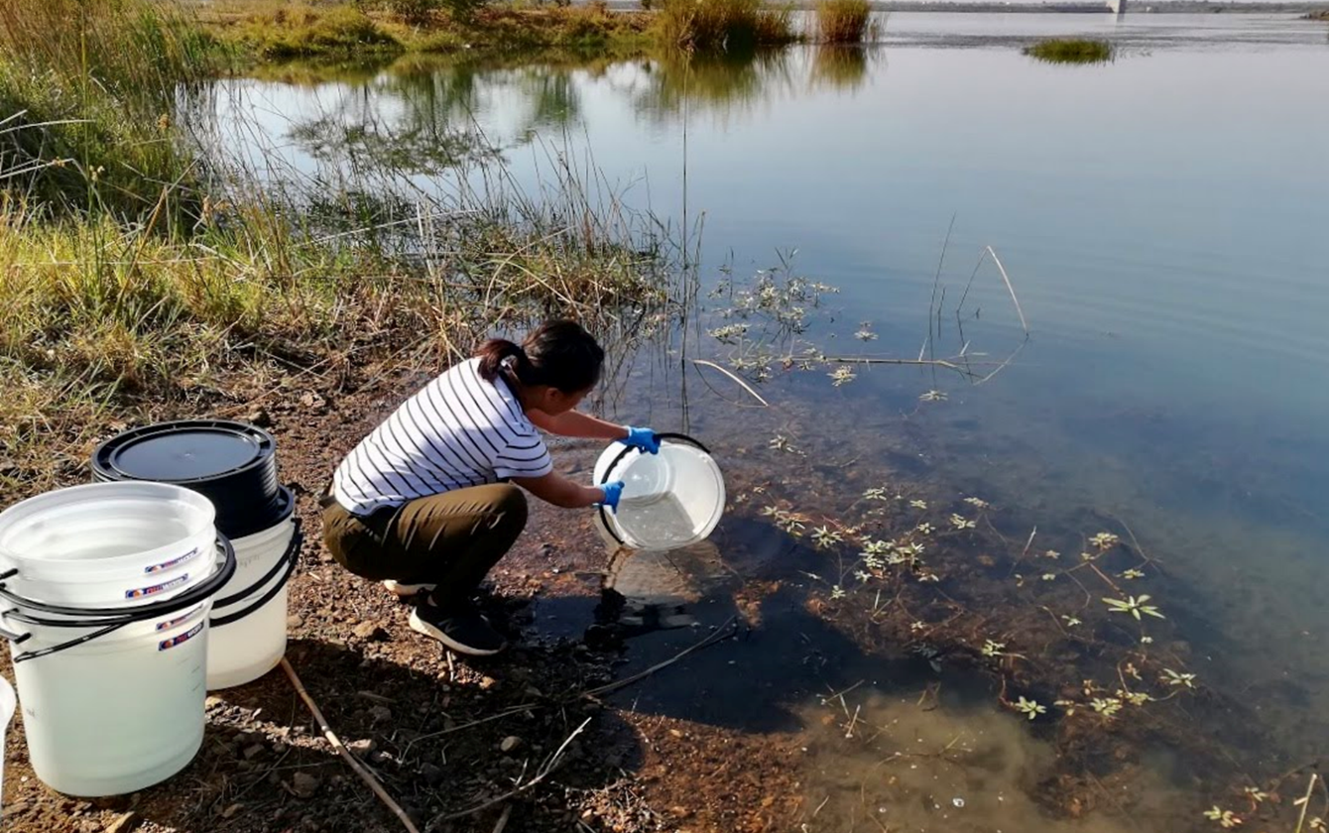
Abstract
Background: Developing easy-to-use, effective, socially acceptable, and inexpensive methods to treat water is critical. The MadiDrop+ is a ceramic tablet embedded with nanopatches that release silver ions during point-of-use water treatment. Silver is an effective disinfectant for bacteria, but not viruses. Contrastingly, chlorine is highly effective against viruses. The goal of the study is to investigate the synergistic effects of silver and chlorine to maximize point-of-use water treatment. Additionally, we investigated the effects of the addition of chlorine at different concentrations on the release rate of silver ions in the MadiDrop+. Methods: Untreated water samples were analyzed using membrane filtration and free chlorine and silver measurements. Treatment groups measured the effect of just a MadiDrop+, just chlorine, and both a MadiDrop+ and chlorine to assess total coliform disinfection. Outcomes: Silver and chlorine synergistically resulted in the highest average log reduction (3.77) of total coliform bacteria after 3 hours, then just silver treatment (2.17) and just chlorine treatment (0.29). The addition of 0.2ppm chlorine with the MadiDrop+ is ideal for the lowest release of silver ion into the water, while still achieving a high log reduction of total coliform bacteria. Discussion: It appears that there was greater coliform disinfection in the treatment group that involved both free chlorine and silver ions from a MadiDrop+. Conclusion: The research conducted was preliminary to access possible areas of improvement for the MadiDrop+. Further implications include quantifying the inactivation of adenovirus and enterovirus inactivation using silver and chlorine.

Introduction
Water connects every aspect of life. Access to safe water and sanitation can quickly turn problems into potential, empowering people with time for school and work, and contributing to improved health for women, children, and families around the world. Each year, more than 1.5 million children die globally from consumption of water contaminated with pathogenic microorganisms, with countless more suffering from cognitive impairment and growth stunting [1]. Additional health and life outcomes include cognitive impairment, poor school performance, low adult economic productivity, and increased risk of chronic disease later in life [2].
Developing easy-to-use, effective, socially acceptable, and inexpensive methods to treat water is critical. The MadiDrop+ (MD) is a low-cost porous ceramic tablet embedded with metallic silver nanopatches that release silver ions during point-of-use water treatment. The purpose of the MadiDrop+ is to disinfect the household’s daily water supply, address residual contamination left behind by other water treatments, and protect stored water from contamination. The MadiDrop+ has an unlimited shelf life and is easy to store until needed. Once placed in water, the product is effective for up to twelve months. The MadiDrop+ is to be placed in a container filled with 10-20L of water daily. Users should wait 8 hours before drinking the water if the water was clear and 24 hours if the water was dirty.
Once the MadiDrop+ in placed in water, it consistently releases precise amounts of silver ions (about 20-63ppb silver ions in 10L of water after 24 hours). Ionic silver is an effective disinfectant for all bacterial waterborne pathogens, like E. coli and V. cholerae, and moderately effective for protozoan pathogens, like Cryptosporidia [3]. However, silver is not highly effective for disinfection of viral pathogens, such as adenovirus.
Contrastingly, conventional free chlorine (hydrochloric acid), is highly effective against viruses and bacteria, but is ineffective against protozoa. Disadvantages of using chlorine include relatively low protection against protozoa and bad taste and odor [4]. The goal of the study is to investigate the synergistic effects of silver and chlorine to ideally maximize point-of-use water treatment. Additionally, the effects of the addition of chlorine on the release rate of silver ions in the MadiDrop+ were investigated. This research project was conducted in Thohoyandou, South Africa in Limpopo Province. All lab work was conducted at the University of Venda in Limpopo Province.
Methods
Water samples were collected in 10L plastic buckets from a nearby stream right outside the front gate of the University of Venda. Membrane filtration technique was used to quantify to E. coli and total coliform bacteria levels as indicators of disinfection rates. Membrane filtration utilized a membrane filtration manifold, 0.45µm pore filtration paper, 47mm petri dishes, Coli-blue bacteria growth media, and an incubator. Manifold cups were sanitized between each sample to prevent contamination through boiling them in a water bath. Tests were conducted in rounds with three 100mL samples in each round. For each sample, both a full and 1/100 or 1/10 dilution was run, depending on the initial coliform count of the untreated water sample. The samples were then incubated for 24 hours at 36°C to allow for bacteria growth. Colonies were then counted and recorded after the incubation period. The addition of chlorine treatment during the experiments was by the addition of a chlorine solution created by dissolving 43mg AquaTabs in water for the desired chlorine concentration. In addition to membrane filtration, free chlorine and silver ion concentration levels were measured using a Hach spectrophotometric method and atomic-absorption spectrometry, respectively. Free chlorine concentration was collected to assess the actual concentration of free chlorine in the treated water, while silver ion concentration was an indicator of silver release rate from the MadiDrop+.
Testing the synergistic effect of silver and chlorine
Seven 10L buckets filled with collected untreated stream water were exposed to 4 treatment groups: untreated, only MD (MadiDrop+) (~20-63ppb silver ions in 10L after 24 hours), only chlorine solution (0.1ppm), and MD+Cl (~20-63ppb silver ions and 0.1ppm Cl) solution. One of the seven buckets was an untreated control, while the others were duplicates of each of the remaining 3 treatment groups. Samples for membrane filtration, chlorine, and silver analysis were taken at times 0hr, 1hr, and 3hrs after initial treatment.
Testing the effects of chlorine on the MadiDrop+’s release of silver ions
Nine 10L buckets were filled with untreated stream water, one bucket was an untreated control, while the others were duplicates each of the 4 treatment groups. A MadiDrop+ was placed into each bucket and exposed to different concentrations of Cl (0ppm, 0.05ppm, 0.1ppm, 0.2ppm). Sampling occurred at 6 different time points (0hr, 0.5hr, 1hr, 2hrs, 4hrs, 8hrs) after initial treatment.
Outcomes
The synergistic effect of silver and chlorine
Figure 1 shows the average log reduction of total coliform bacteria over 3 hours of treatment. When comparing the effectiveness of each treatment group (only MD, only Cl, and MD+Cl), 1 hour and 3 hours after initial treatment, the treatment of just 0.1ppm chlorine solution had the least average log reduction when compared to the treatments with the MadiDrop+. While the average log reduction of the MD+Cl group is lower than the MD group at T=1, disinfection was much greater at T=3. Silver and chlorine synergistically have a higher disinfection rate (log reduction of 3.77) of total coliform bacteria after 3 hours, than just silver treatment (log reduction of 2.17) and just chlorine treatment (log reduction of 0.29), as shown in Figure 1. The addition of chlorine with the MadiDrop+ increased disinfection of total coliform by almost 2 logs compared to just the disinfection using a MadiDrop+.
The effects of chlorine on the MadiDrop+’s release of silver ions
Figure 2 displays the average log reduction of total coliform bacteria over 8 hours. At 8 hours, the MadiDrop+ and 0.2ppm free chlorine treatment had the highest. At T=0.5, all of the treatment groups did have an increase in coliform bacteria compared to their original amount. This may be due to the natural growth rate of coliform bacteria from within the buckets being greater than the rate of disinfection.
Figure 3 displays silver ion concentration over 8 hours. The MadiDrop+ and 0.2ppm free chlorine treatment group had the lowest concentration of silver ions of 1.075ug/L compared to the rest of the treatment groups. Meanwhile, the MadiDrop+0.1ppm Cl treatment group had the highest silver ion level of 11.17ug/L after 8 hours. In conclusion, the addition of 0.2ppm chlorine with the MadiDrop+ is ideal for the lowest release of silver ion into the water, while still achieving a high log reduction of total coliform bacteria (2.79)
Discussion
There was greater coliform disinfection in the treatment group that involved both free chlorine and silver ions from a MadiDrop+, as shown in Figure 1. There appears to be a synergistic disinfection effect on coliform bacteria between silver and chlorine, which makes sense, given the antimicrobial properties of each chemical. Given that there is a synergistic effect between silver and chlorine, the chemical interactions of the two should be analyzed. It is important to investigate how chlorine interacts with the silver ions in the MadiDrop+ at varying concentrations. We do not want chlorine to release more silver ions than the MadiDrop+’s current rate because of the risk of overexposure to silver in drinking water. Additionally, we want an ideal concentration of chlorine to add to the MadiDrop+ to maximize coliform disinfection. Adding a chlorine solution of 0.2ppm to the MadiDrop+ resulted in the highest log reduction of coliform bacteria over 8 hours, as shown in Figure 2. This result makes sense since the treatment had the highest concentration of chlorine compared to the other treatment groups. A higher concentration of chlorine should result in a higher reduction of coliform. It was interesting that the addition of 0.2ppm free chlorine with the MadiDrop+ resulted in such a drastically lower silver ion release than the other lower concentrations of chlorine, as shown in Figure 3. The chemical mechanism behind this result is currently unclear. Further analysis on how chlorine interacts with the silver nanopatches of the MadiDrop+ that will require more knowledge on how the product is chemically engineered. Additionally, the release rate of the silver ions of the MadiDrop+s could have varied more drastically between each other than expected and thus have resulted in lower release rates regardless of the addition of chlorine.
A limitation of the study was the variability of the total coliform counts of the untreated stream water. The stream water collected had very high coliform counts and high turbidity, which made it difficult to identify the correct dilution for membrane filtration samples. While, turbidity was not qualitatively assessed in this study, turbidity of the stream water increased throughout the summer due to a nearby construction site. Turbidity may have an effect on disinfection through interference in the disinfection process of free chlorine and silver ions in the water. Turbidity in water could not be reduced by the MadiDrop+, since it is just a ceramic tablet you place in the water and not a traditional water filter. Additionally, the silver ion concentration range for MadiDrop+s is about 20-63ppb after 24 hours in water. They varying ranges of silver ions released in the shorter 8-hour period of the experiment could have affected disinfection rates. Lastly, another limitation of the study was the lack of assessment of viral inactivation of silver and chlorine synergistically, since the main reason for adding chlorine was to increase viral inactivation that is less effective when using just silver.
Conclusion
The research conducted was preliminary to access possible areas of improvement for the MadiDrop+ to make it more effective in disinfection and more affordable to consumers. More analysis must be done to conclude an effective ratio of chlorine and silver for total coliform disinfection. Further implications include implementation of the MadiDrop+ to directly release free chlorine into contaminated water along with silver ions, quantifying the inactivation of adenovirus and enterovirus inactivation using silver and chlorine, and human health trials to assess sustainable use of product, as well as if the addition of chlorine impacts taste of filtered water.
References (AMA)
- Dillingham R, Guerrant RL. Childhood stunting: measuring and stemming the staggering costs of inadequate water and sanitation. The Lancet. 2004;363(9403):94-95. doi:10.1016/s0140-6736(03)15307-x.
- Victora CG, Adair L, Fall C, et al. Maternal and child undernutrition: consequences for adult health and human capital. Lancet 2008; 371: 340–57.
- Singh R, Edokpayi JN, Odiyo JO, Smith JA. E. coli Inactivation by Metals and Effects of Changes in Water Chemistry. Journal of Environmental Engineering. 2019;145(2):04018136. doi:10.1061/(asce)ee.1943-7870.0001486.

- Sedlak DL, Gunten UV. The Chlorine Dilemma. Science. 2011;331(6013):42-43. doi:10.1126/science.1196397.
Acknowledgements
This research project could not have been possible without the help from the Center for Global Health, Professor James A. Smith and Ana Estrella-You from the University of Virginia: Civil and Environmental Engineering Department, Professor Joshua Edokpayi from the University of Venda Hydrology Department, and Professor Samie Amidou from the University of Venda Microbiology Department.

Appendix:
Figure 1:
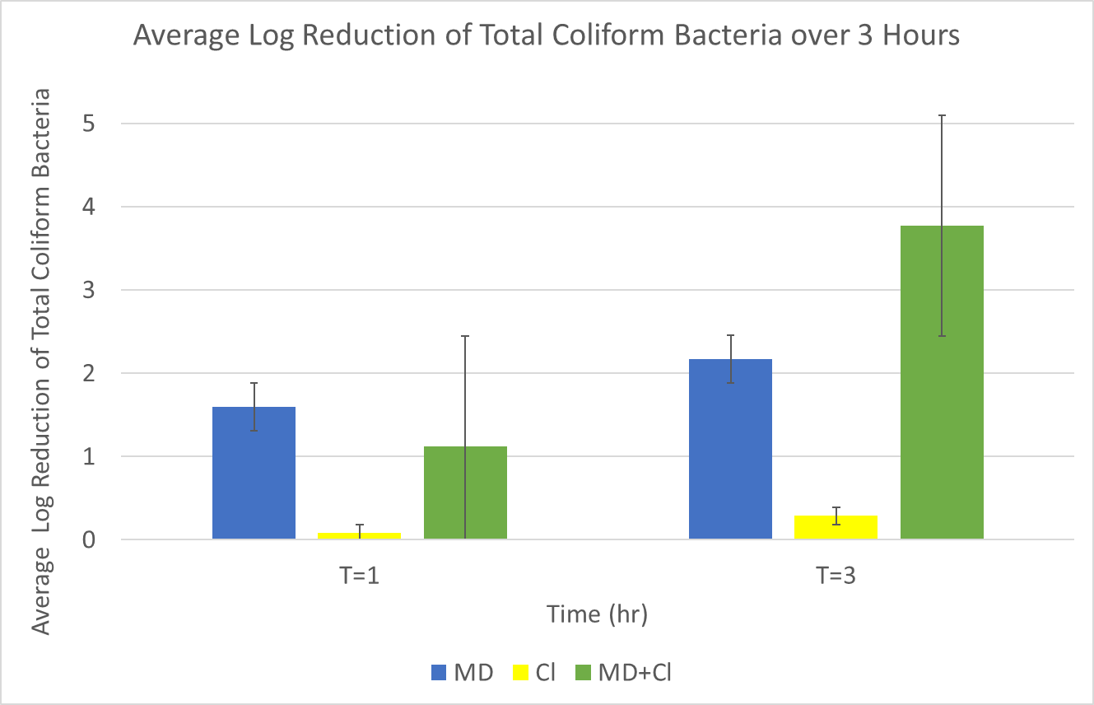
Key:
MD = Only MadiDrop+ treatment (~20-63ppb silver ions in 10L after 24 hours)
Cl= Only chlorine treatment (0.1ppm)
MD+Cl= Treatment with both MadiDrop+ and chlorine solutions
Figure 2:
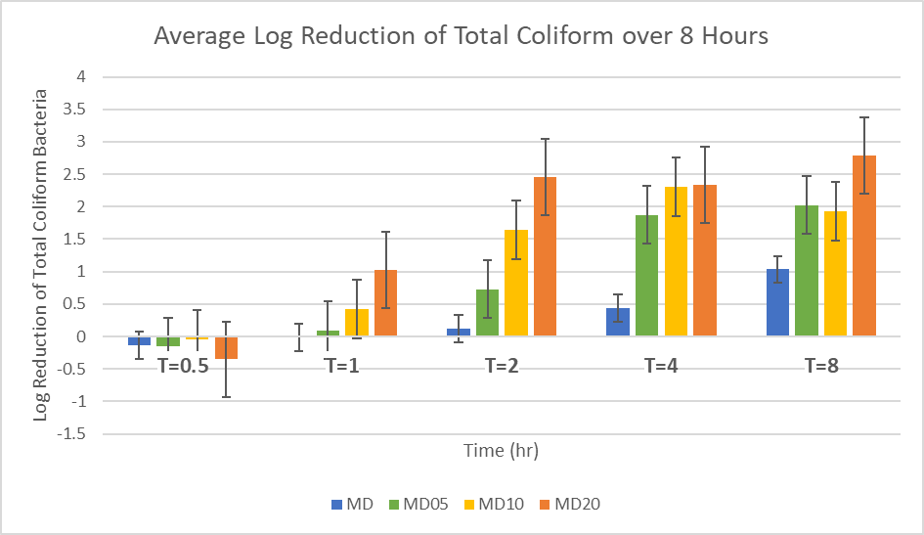Key:
MD= Only MadiDrop+ (no chlorine solution)
MD05= MadiDrop+ and 0.05ppm chlorine solution
MD10= MadiDrop+ and 0.1ppm chlorine solution
MD20= MadiDrop+ and 0.2ppm chlorine solution
Figure 3: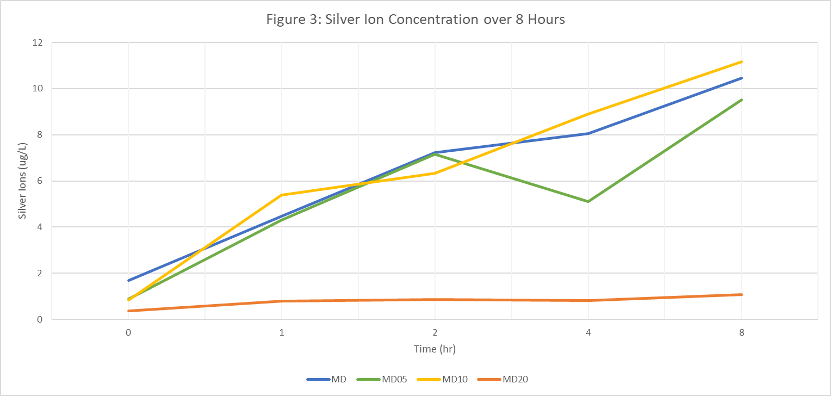
Key:
MD= Only MadiDrop+ (no chlorine solution)
MD05= MadiDrop+ and 0.05ppm chlorine solution
MD10= MadiDrop+ and 0.1ppm chlorine solution
MD20= MadiDrop+ and 0.2ppm chlorine solution

