Title: Water Supply and Microbiology Quantification at the University of Venda in Limpopo, South Africa

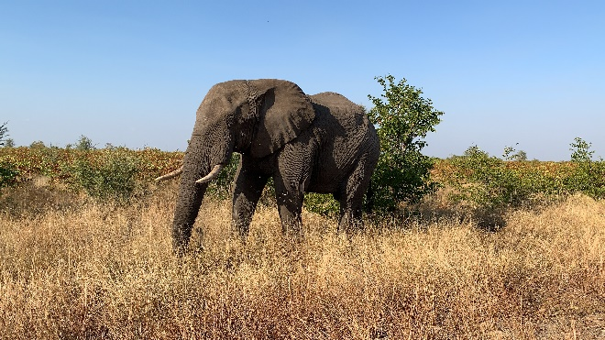
Abstract:

Clean water is essential to almost all aspects of human life and is a major concern for communities around the globe, especially in the rural Limpopo province of South Africa. As clean water is a significant concern for the University of Venda (UNIVEN), at the request of Jan Crafford, Deputy Vice Chancellor, a comprehensive analysis of the water quality and supply at UNIVEN was completed during the summer of 2019. The analysis included three main parts: determination of the delivery and supply of water from the municipality treatment works, quantification of E.coli and coliform bacteria in the groundwater and municipality water at point-of-use at UNIVEN, and free chlorine analysis of municipality water at the treatment works and point-of-use at UNIVEN to examine the effects of the distribution network on free chlorine residuals. Preliminary results find considerable differences in the water quality from the municipality treatment plant and groundwater sources, with overall quality of municipality water being much higher than groundwater, according to microbiological indicators. These results strongly suggest treatment is essential for groundwater before consideration as a source of clean water for continued consumption by the general population of UNIVEN.

Background:

In today’s developing countries, access to safe water and sanitation services is not always consistently available. Contaminated water and lack of sanitation have been linked to approximately 80% of illness in the developing world and have been heavily associated with early childhood diarrhea. Early childhood diarrhea is estimated to cause 1.5 million child mortalities per year worldwide and is the leading cause of death of children under age five in developing countries [1]. In addition, childhood diarrhea has been associated with impaired physical fitness, growth, and cognitive function during development, even when controlling for factors such as socioeconomic status [2]. In July 2010, unrestricted access to safe, sufficient, clean water was recognized as a basic human right by the United Nations General Assembly [3]. Today, however, a tenth of the global population (around 800 million people) still lack access to basic water and sanitation services [4].

South Africa has been identified as a country that faces a significant water challenge [5]. This challenge is especially prominent in rural villages where the majority of the population relies on groundwater from boreholes as their primary source of drinking water [6]. Access to water is only part of the problem; South Africa faces a growing problem with water toxicity due to increased bacterial growth found in their water sources from the expansion of the agricultural sector and booming economic growth in the past two decades. South Africa has recognized this issue and spent significant resources towards increasing water equality and accessibility. In 2018, the Department of Water and Sanitation developed the National Water and Sanitation Master Plan, outlining both current problems and a plan for the future, hoping to increase efficiency in treatment and distribution processes and provide clean, safe water to 100% of their citizens by 2030 [7].

Access to clean water is absolutely essential, especially at schools and universities. Jan Crafford, Deputy Vice Chancellor at the University of Venda (UNIVEN), requested a comprehensive analysis of the water quality and supply at UNIVEN. UVA and the Center for Global Health provided support for the project thanks to an enduring relationship between UVA and UNIVEN. Currently, UNIVEN relies on two main sources for water, a municipal water treatment works and existing on-campus boreholes. The water supplied by the municipality comes from the Nandoni Water Treatment Works (Nandoni WTW), located at the Nandoni Dam on the Luvuvhu River. Presently, Nandoni WTW supplies approximately 50 megaliters of water to UNIVEN per month, and existing boreholes supply only a small fraction of the water at UNIVEN, as their primary purpose is for agricultural and construction use. Due to an increase in water demand and the growth of the surrounding area of Thohoyandou, among a myriad of other factors, the water supply to UNIVEN from Nandoni WTW can be inconsistent, sometimes cutting off for just a few hours or even days at a time. As a result, UNIVEN plans to drill additional boreholes on campus to utilize groundwater to ensure a consistent, available supply of water, eventually hoping to solely rely on boreholes to meet the water demands of the University.

Methods:

Focus #1: Microbial Quantification of Groundwater and Municipal water at UNIVEN

With the assistance of UNIVEN students and faculty, thirteen taps located across the UNIVEN campus were selected and sampled semiweekly, eight serviced by Nandoni WTW, and five serviced by existing boreholes. The distribution of sampled taps, both borehole and municipality serviced, at the UNIVEN campus is shown in Figure 6, Appendix A. In addition, three 10,000-liter water storage tanks, called JoJo tanks, were also sampled weekly. However, these JoJo tanks could be filled with both municipality and borehole water and were therefore disregarded in analysis as it was unclear what proportion of water from each source was present in the tanks. The selected taps represented approximately half of the taps available at UNIVEN and were selected based upon high-traffic volumes in order to most accurately represent the drinking water of the student population. When sampling, taps were allowed to run for a full minute before the official sample was taken. Additionally, samples were taken twice, and the results were averaged to ensure more accurate results.

Coliform and E.coli bacteria were selected as indicators of contamination due to their relatively long survival time in water and ease of detection, especially in low numbers. Coliform bacteria presence is an indicator that contamination stems from soil and vegetation, while E.coli bacteria presence likely indicates fecal contamination and the possibility of other intestinal pathogens. Collected samples were brought back to the UNIVEN lab and immediately tested for coliform and E.coli bacteria using membrane filtration methods. After filtration and incubation for 24 hours at 37 °C, to simulate growth in the human body, colony forming units of both coliform and E.coli were counted and recorded. Due to the size of the dish, samples with colony counts over 300 became difficult to count as the colonies overlapped and were therefore recorded as “over 300”. Unfortunately, due to a fault in the experimental design, dilutions were not run, and if the number of colonies in the full-strength sample exceeded the maximum of 300, the true value of coliform bacteria per 100mL could not be calculated. Along with the samples, blanks, using deionized (DI) water, were run to ensure no errors were made in the procedure. If the blank showed signs of coliform growth, the samples ran alongside the blank were disregarded in analysis.

After microbiological quantification, municipal samples were analyzed for free chlorine residual via spectrophotometer and Hach DPD free chlorine test tube kit. During treatment at Nandoni WTW, chlorine, in the form of chlorine gas, is added to remove microbiological pathogens. A free chlorine residual remains in the treated water as a precautionary measure against post-treatment contamination, usually on the scale of 0.2 mg/L to 1.0 mg/L, although it is safe up to 5 mg/L, according to a 1996 WHO study [8]. 10mL of collected sample was mixed with DPD reagent. Absorbance and transmittance of visible light at wavelength 530nm were recorded and free chlorine concentration was calculated based on a calibration curve. To ensure accuracy, blanks were run with each sample, using DI water and no DPD reagent.

Focus #2: Quantification of Free Chlorine Residuals at Nandoni WTW and Point-of-Use

After approval from the director at the Nandoni Water Treatment Works to tour the facilities and sample the influent and effluent water, weekly visits allowed for better understanding the treatment process and established rapport between Nandoni WTW and UNIVEN. Weekly influent and effluent samples were brought back to UNIVEN and analyzed for coliform, E.coli, and free chlorine using the aforementioned membrane filtration methods. Nandoni WTW also granted access to its records of water quality, specifically: measurements of pH, turbidity, total dissolved solids, and free chlorine residuals in influent and effluent water with measurements of these quality indicators recorded every two hours. The records for the month of July 2019 were compared against quality indicators at the point-of-use at UNIVEN, and to examine trends in quality from effluent water to point-of-use. These records also shed light into how daily and weekly variations in free chlorine residuals at the water treatment plant affected coliform bacteria and free chlorine residuals at the point of use at UNIVEN.

Results:

Result #1: Groundwater Quality at UNIVEN

Over the course of the testing period, 43 borehole samples were tested and microbiological analysis revealed high levels of coliform and E.coli contamination. Figure 1 (left) shows the daily quartile ranges of coliform bacteria in borehole samples. Although variation is present between the daily means and medians, the overall pattern confirms the strong indications of contamination throughout the entire testing period. Figure 1 (right) also displays the distribution of coliform counts in borehole samples, a multi-modal distribution with peaks at 300+, ~200 and ~50. Tallying the results show 97.6% of borehole samples have measurable indications of coliform colony growth, and 60.4% of borehole samples contained more than 100 colonies per 100mL. It is also of importance that there was no significant difference in the average coliform colony counts in samples from individual borehole taps, signifying that contamination is present in borehole taps across the UNVIEN campus. Figure 2 (left) displays the E.coli quartile ranges for collected borehole samples. These quartile ranges show that the median E.coli count was low for most sampling days; however, any indications of fecal contamination present a significant risk for exposure to fecal pathogens. From the histogram of E coli Bacteria in Borehole samples, Figure 2 (right) , it is essential to note that 48.8% of borehole samples showed some E.coli colony growth. Overall, borehole samples contained, on average, 152.9 ± 103.3 colony forming coliform units and 7.2 ± 15.7 colony forming E.coli units per 100mL, posing serious health risks for both long and short term consumption for faculty and students. At UNIVEN, there is currently no treatment process used for borehole water, hence no free chlorine was present in any borehole samples. A turbidimeter was not available in the laboratory at UNIVEN, however, a relatively low turbidity is suspected in borehole samples, as no significant discoloration was visible on the filter during the membrane filtration process.

Result #2: Municipal Water Quality at UNIVEN

Over 90 total samples of UNIVEN taps serviced by Nandoni WTW were tested, and in stark contrast to the microbiology of the borehole serviced taps, showed little indications of coliform or E.coli contamination. Figure 3(left) shows the daily quartile ranges for coliform bacteria in municipal samples, in which the median and mean were under 5 colony forming units per 100mL for 75% of sampling days. There were a few instances of high coliform counts, however, these usually occurred after municipal water outages. During the six-week testing period, municipal water was cut to UNIVEN for a three-day period and two additional periods lasting less than a day, with exact duration unknown. The cause of these outages is still unclear, except for the three-day outage, the catalyst being a local village, that had not received water for over two weeks, striking, hindering Nandoni WTW’s ability to provide water to the rest of Thohoyandou. The data shows that 81% of samples of taps serviced by Nandoni WTW contained less than 5 colony forming coliform units per 100mL, and on average, only 5.2 colony forming coliform units per 100mL, indicating low risk of infectious disease transmission and an effective treatment process. There were no indications of E.coli bacteria or fecal contamination in any municipality serviced samples.

Figure 3 (right) also displays the quartile ranges for free chlorine residuals in samples from municipal taps at UNIVEN, displaying large differences in daily quartile ranges. Only 48.8% of samples collected from municipality serviced taps contained any free chlorine residual. When a free chlorine residual was present, only 27.2% of collected samples had a free chlorine residual over 0.10 mg/L. There was a correlation between the presence of a free chlorine residual and the absence of coliform bacteria colonies in municipal samples, apparent from comparing the free chlorine quartile ranges and coliform quartile ranges in Figure 3. The inverse relationship between coliform bacteria and free chlorine residuals in municipal samples is apparent especially from July 4th, 2019 through July 16th, 2019. Overall, the average of free chlorine residuals of municipal samples at UNIVEN was 0.085 mg/L, a fraction of the free chlorine residual leaving the plant.

Result #3: Effluent Water Quality at Nandoni Water Treatment Works

At Nandoni WTW, the treatment process is broken down into four stages: coagulation/flocculation, settling, filtering, and finally chlorination. The treatment process begins with the addition of Superfloc™ chemicals to the influent water and then passed through coagulation/flocculation tanks, containing zig-zagging walls where tiny particles collide to form larger ‘flocs’, which are much easier to filter out later in the process. The water is then passed into a settling tank which reduces the turbulence of the water and prepares it to pass through a series of filters, methodically removing flocs and reducing the turbidity of the water to under 1 NTU. During the final stage, chlorine gas is added to remove microbiological contaminants. The operations scheme (Figure 4) is used to determine levels of chlorine gas to be added, as well as to self-evaluate the general operations of Nandoni WTW.

All collected effluent samples from Nandoni WTW showed no indications of microbiological contamination. This is a full reduction from the average of 101.3 colony forming coliform bacteria present in samples collected from the influent water at the treatment plant, highlighting the effectiveness of the treatment process at Nandoni WTW. The mean free chlorine residual in the effluent water in the bihourly measurements recorded by Nandoni WTW for the month of July 2019 was 0.60 mg/L, the lower bound of the target range of the operations scheme (Figure 4) laid out by the treatment plant. The standard deviation of these measurements was 0.267 mg/L, and subsequently only 26% of the bihourly measurements fell in the target range for free chlorine residuals. Further, 56% of the measurements fell in the Lower Warning Limit, and only 9% were in the Upper Warning Limit. (Figure 5)

Discussion:

According to the guidelines laid out by the Department of Water and Sanitation of the South African government, the target range for coliform bacteria present in domestic use drinking water is between 0 and 5 coliform bacteria per 100mL. This target range reflects “proper treatment and offers negligible risks of infectious disease transmission” [9] (Appendix A, Figure 7). Around 80% of samples from taps serviced by Nandoni WTW fell into this range, indicating water quality from the municipality treatment plant is good most of the time. However, the remaining 20% of municipal samples, and the high variability in free chlorine residuals indicate some level of post-treatment contamination along the distribution network. This suggest a supplemental point-of-use treatment or refinements to the chlorine treatment at Nandoni WTW would ensure the highest water quality for students and faculty. In conversations with Nandoni WTW, there is currently discussion about post-treatment chlorination along the distribution network, or increases in the chlorine doses during the treatment process.

Unfortunately, 60.4% of borehole samples contained over 100 coliform colony forming units per 100mL, which according to South Africa’s Department of Water and Sanitation, poses significant human health risks with long-term consumption [9] (Appendix A, Figure 7). Additionally, E.coli contamination in 48.8% of borehole samples indicates fecal contamination. Fecal contamination indicates the possibility of other intestinal pathogens presence in the water and future research into these other bacteria/viruses in the water would prove helpful in selecting an effective treatment processes. Overall, data suggests it would be advisable to treat the borehole water at UNIVEN before use as the principal source of drinking water for the student population. Use of chlorine or silver treatment such as the MadiDrop in the JoJo tanks used to store the borehole and municipality water would effectively combat both post-treatment contamination in municipal water and any contamination in the borehole water. Additionally, the low turbidity levels in the borehole samples suggest that chlorine or silver nanoparticle point-of-use treatment would be effective, as they have been shown to reduce coliform and E.coli bacteria on a 5-log scale in the presence of low turbidity [10] .

The microbiological analysis was constrained by the eight weeks physically spent in South Africa. Long-term trends in coliform and E.coli bacteria in the borehole and municipal samples were unable to be analyzed. Hopefully, students will continue research into the water quality at UNIVEN. Additionally, the six-week testing phase was entirely during the dry season, and the effects of run-off on the municipality distribution network in the heavy rain season were not able to be examined. This is especially important with the municipal taps at UNIVEN, with only about half of samples showing a free chlorine residual, possible post-treatment contamination from runoff could have major effects on the point-of-use quality at UNIVEN. Another limitation of the study is that the only two operational boreholes that supplied water to the university, out of the eight total boreholes, were located in the Agriculture School and on a construction site, both with high possibilities of coliform and E.coli contamination. Future research into boreholes located in other areas around UNIVEN would provide valuable information when the boreholes become operational, as well as for any additional boreholes drilled.

Conclusions:

High levels of coliform and E.coli bacteria present in borehole samples indicate potential human health effects with long-term consumption of borehole water and some form of microbiological treatment is recommended. However, as this is the first research into the microbiology of the groundwater and municipality water at UNIVEN, more research is required to fully understand the potential human health effects for the students and faculty at UNIVEN. Nevertheless, with continued studies and diligence by researchers and administration, the University of Venda will confidently be able to provide students and faculty with easily accessible clean water.

Figures:
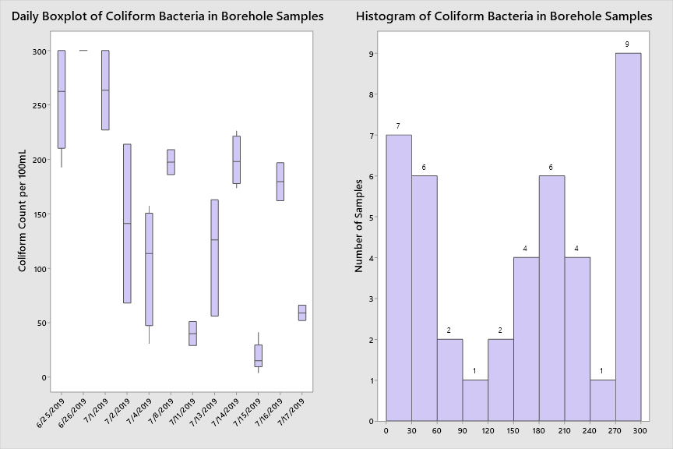
Figure 1. Boxplots and Histogram of Coliform Bacteria in Borehole Samples at UNIVEN
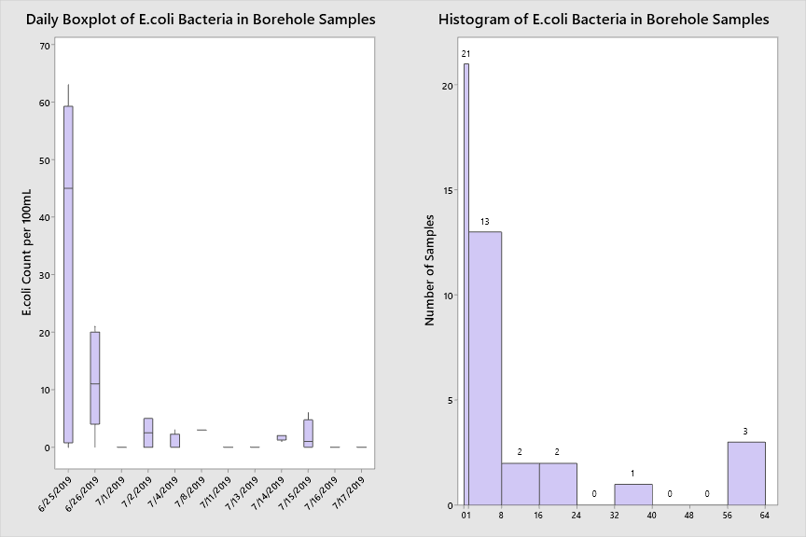
Figure 2. Daily Boxplots and Histogram of E.coli in Borehole Samples at UNIVEN
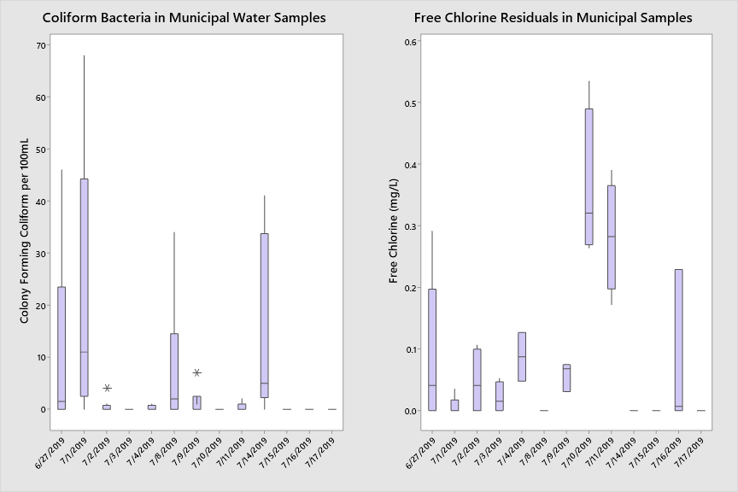
Figure 3. Boxplots of Coliform and Free Chlorine Residuals in Municipal Samples at UNIVEN
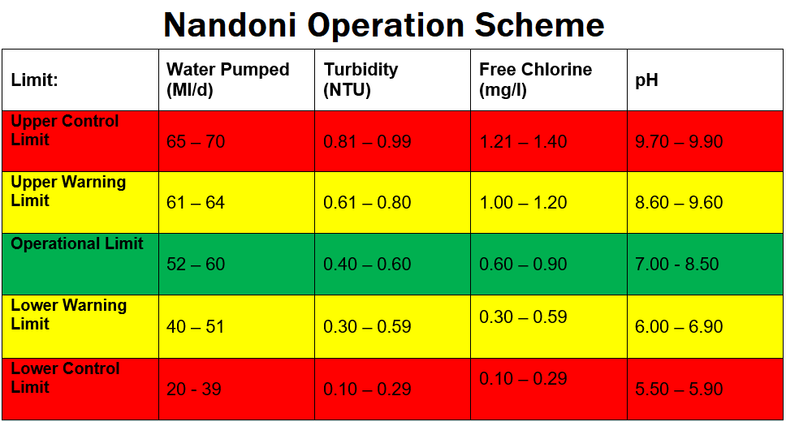
Figure 4. Nandoni Water Treatment Works Operational Scheme
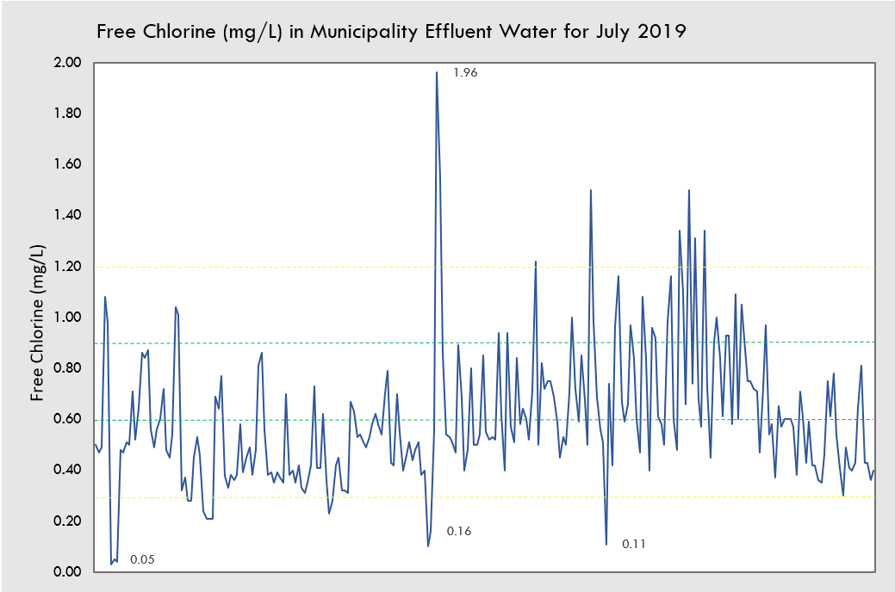Figure 5. Time Series of Bihourly Measurement of Free Chlorine Residuals in Effluent Water at Nandoni WTW

References:

- Drinking-water. World Health Organization. https://www.who.int/news-room/fact-sheets/detail/drinking-water. Accessed October 24, 2019.

- Lorntz B, Soares AM, Moore SR, et al. Early Childhood Diarrhea Predicts Impaired School Performance. The Pediatric Infectious Disease Journal. 2006

- UN Committee on Economic, Social and Cultural Rights (CESCR), General Comment No. 15: The Right to Water (Arts. 11 and 12 of the Covenant), 20 January 2003

- Progress on household drinking water, sanitation and hygiene 2000-2017. Special focus on inequalities. New York: United Nations Children’s Fund (UNICEF) and World Health Organization, 2019.

- Charting Our Water Future: Economic frameworks to inform decision-making. 2009. https://www.mckinsey.com/~/media/mckinsey/dotcom/client_service/sustainability/pdfs/charting our water future/charting_our_water_future_full_report_.ashx. Accessed October 26, 2019.

- Water Access in South Africa. Water Access in South Africa | Water for all. http://12.000.scripts.mit.edu/mission2017/case-studies/water-access-in-south-africa/. Published 2009. Accessed October 26, 2019.

- Department of Water and Sanitation. National Water and Sanitation Master Plan. Vol 2. 31 March 2018.

- Guidelines for drinking-water quality, 2nd ed. Vol.2. Health criteria and other supporting information. World Health Organization, Geneva, 1996.

- Department of Water Affairs and Forestry, 1996. South African Water Quality Guidelines (second edition). Volume 1: Domestic Use.

- McCain K, Gaylord A, Stinger E, Reynolds C. Baseline Testing of the Health Effects of the MadiDrop. Conflux Journal. 2017;2:12-23.

Appendix A.
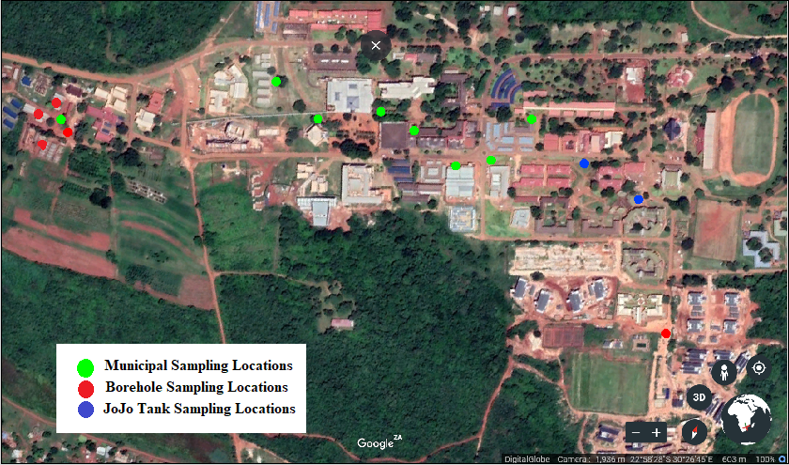

Figure 6. Sampling Locations at UNIVEN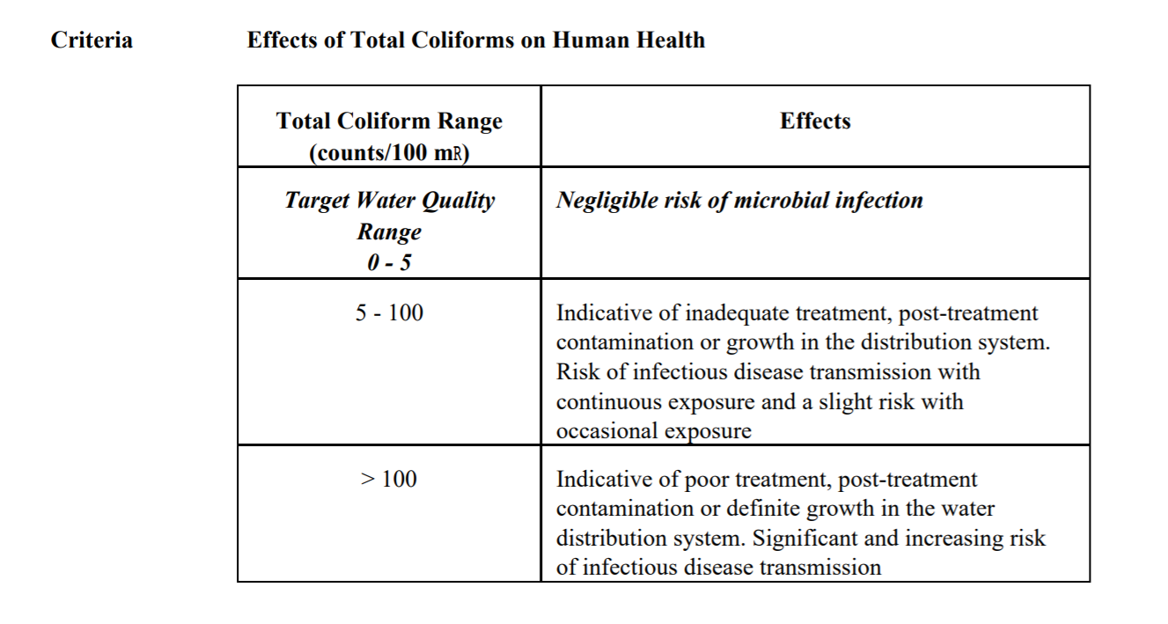
Figure 7. South Africa’s Department of Water and Sanitations Effects of Coliform Bacteria on Human Health

APPENDIX A.
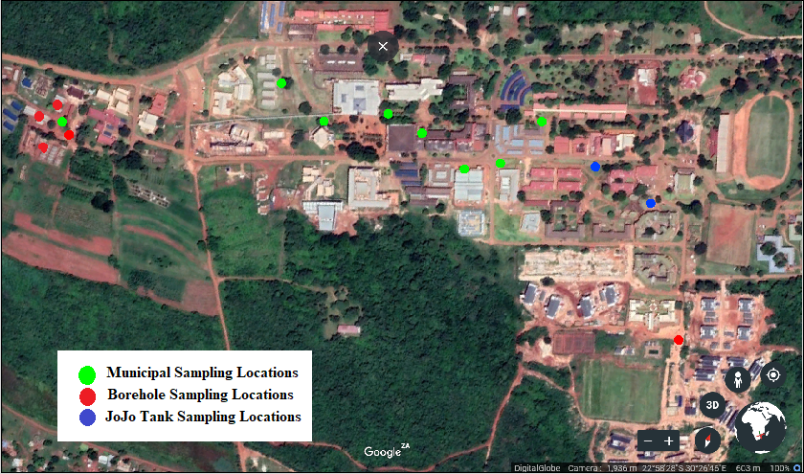
Figure 6. Sampling Locations at UNIVEN

